Question 11 pts
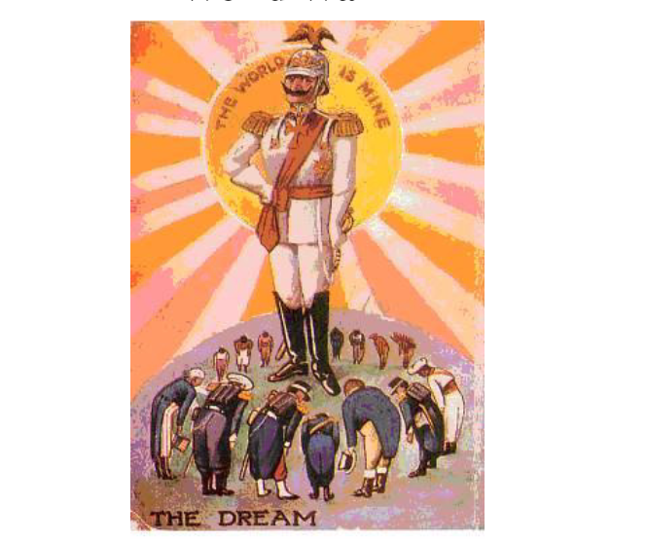

The British postcard above shows what Great Britain feared would happen if the German Kaiser was able to take over many nations all around the world. The German ruler's dream of taking over all the countries of the world is an example of
militarism
communism

patriotism
imperialism

Flag this Question
Question 21 pts
Nationalism is a strong feeling of support for one's nation. The support can mean to be proud of one's country and to want it to be the richest and most important country in the world. Nationalism caused many problems among European countries in the years before World War I. Strong nationalism was a cause of World War I because all the major European powers
wanted to live in peace with other countries.

wanted all the countries to have equal power.
thought the others were more powerful.

wanted to be the most powerful

Flag this Question
Question 31 pts
When a government's top priority is to make sure the country is always ready for a future war, it is called militarism. This early preparation for war was one of the causes of World War I. One example of militarism is
limiting how many immigrants may enter one's country.
taking over other countries around the world.

believing one's own country is the most important.
training all young men to fight in case there is a war.

Flag this Question
Question 41 pts
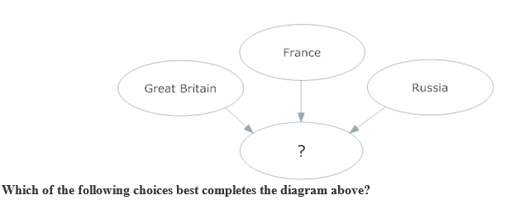
Central Powers
Triple Alliance

Axis Powers
Triple Entente

Flag this Question
Question 51 pts
Over There Hear them calling you and me
Over There Every son of liberty
Send the word Hurry right away
Send the word Don't delay, go today
Over There Make your daddy glad
That the Yanks are coming To have had such a lad
The Yanks are coming
The drums rum-tumming everywhere. from "Over There," by George M. Cohan
The World War I song above tried to glorify war in order to get Americans to join the military and fight. To glorify war means to
tell only the bad things about war
tell the truth about the horrors of war

make people stop fighting each other
make it sound exciting & thrilling

Flag this Question
Question 61 pts
The people of Serbia share a cultural identity with Russia. Both groups are called Slavs. In the years before World War I, Serbia wanted all Slavic peoples to form one empire, free from rule by the Turks or Austria-Hungary. In 1914, Austria-Hungary said that it owned Serbia. This made the Serbs angry because it ruined their dream of having one empire of Slavic peoples. This conflict between Serbia and Austria-Hungary was one cause of World War I. The Serbs' wish to unite all Slavs in one empire is an example of
nationalism
militarism

communism
imperialism

Flag this Question
Question 71 pts
In 1916, U.S. President Woodrow Wilson ran for re-election. During his campaign, he emphasized the fact that he was able to keep the United States out of World War I. In 1917, however, the United States entered the war following which event?
the Zimmerman Telegram revealed Germany would help Mexico in a war against the U.S.
D. America had promised to support Great Britain in a treaty

A. a German submarine sank the British civilian ocean liner Lusitania
C. German agents were suspected of damaging American military supplies

Flag this Question
Question 81 pts
In 1900, the British Empire covered a fifth of the land area of the earth. This led to conflict between the major countries of Europe. Great Britain was trying to conquer Africa from Cairo (in the north) to Cape Town (in South Africa). France was trying to conquer Africa from the Atlantic Ocean to the Red Sea. A few years later, Kaiser Wilhelm of Germany wanted colonies in Africa, too. This angered other major countries and increased the tensions that led to World War I. The desire to take over lands for one's own country to gain more markets and resources is called
patriotism
nationalism

militarism
imperialism

Flag this Question
Question 91 pts
In the years leading up to World War I, European countries like Great Britain and France were very interested in
improving education
reducing taxes

investing in new businesses
expanding their militaries

Flag this Question
Question 101 pts
Great Britain was the largest empire in the world before World War I. Great Britain also had the world's largest navy. Germany's ruler, Kaiser Wilhelm, was jealous of Great Britain's navy. He built many warships so that he could expand the German navy.
The paragraph above describes one of the causes of World War I. Building weapons to prepare a country for a future war is called
imperialism
communism

militarism
nationalism

Flag this Question
Question 111 pts
At the end of World War I, President Wilson prepared a peace plan that called for the creation of the League of Nations, a peacekeeping organization. What prevented the United States from joining the League of Nations?
A. Congress was worried the League would reduce Congress' war powers.
D. France demanded repayment from Germany for war expenses .

C. European leaders rejected too many of Wilson's "Fourteen Points".
B. Great Britain rejected Wilson's call for freedom of the seas.

Flag this Question
Question 121 pts
In the years before World War I, when one major European country built up its army and navy, the other nations
felt they had to do the same .
signed a peace treaty

reduced the size of their military .
got rid of all their weapons.

Flag this Question
Question 131 pts
One of the causes of World War I was imperialism. Imperialism is the system of taking control of many nations. Which of these is an example of imperialism that led to the war?
Some countries were neutral and stayed out of the war.
Russia and Germany were building up their armies.

If one country was attacked, its allies would help defend it.
Austria-Hungary was trying to take over Serbia.

Question 141 pts
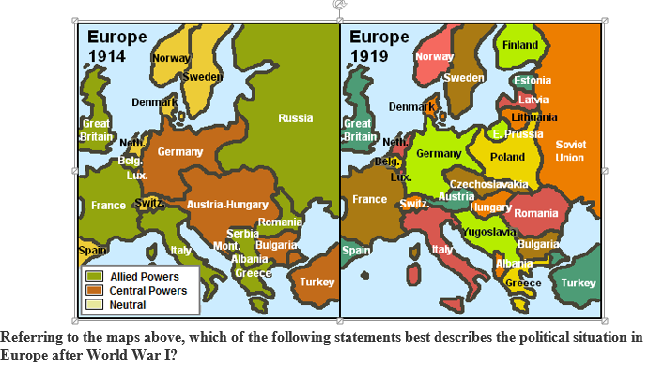
World War I was a decisive victory that resulted in a peaceful Europe.
The Central Powers negotiated a surrender that left them strong economically.

The Old World powers of Central Europe were weakened or destroyed.
The Allies (Triple Entente) emerged from World War I politically stronger.

Question 151 pts
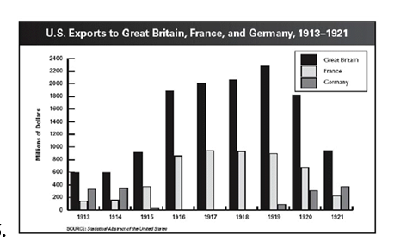
Why did America stop exporting to Germany in 1917?
Germany was self-sufficient
Britain paid more for goods

Russia became Communist
Germany was at war with America

